省赛服饰图片尺码表

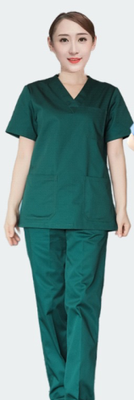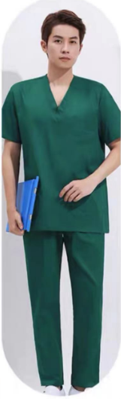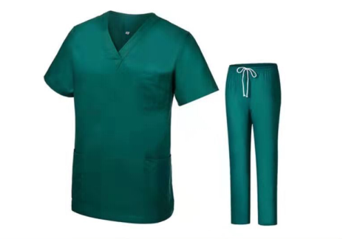

刷手服尺码表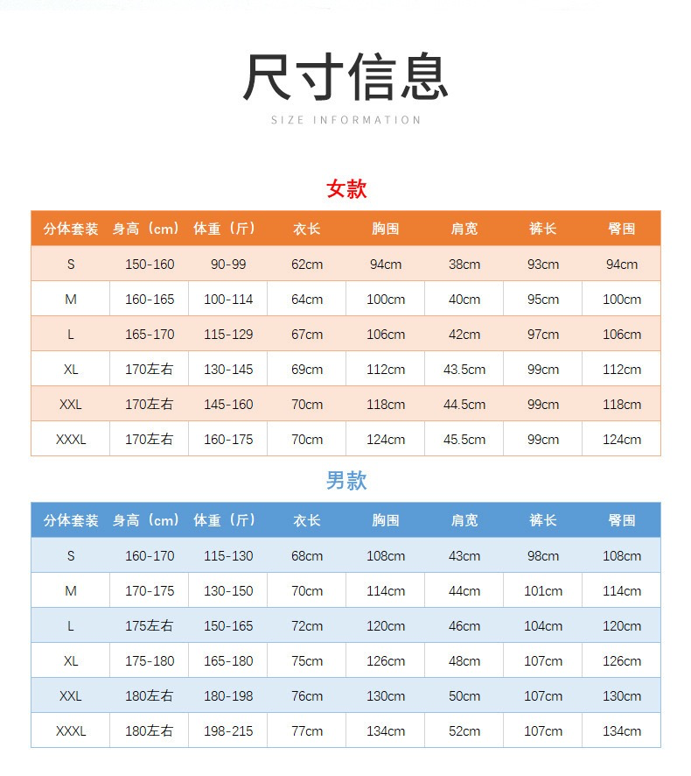



**护士服尺码表**

|  |  |  |
| --- | --- | --- |
| **护士服尺码表(女款）** | | |
| 尺码 | 建议身高(cm） | 建议体重（斤） |
| S | 155 | 90-100 |
| M | 160 | 100-110 |
| L | 165 | 110-122 |
| XL | 170 | 122-134 |
| XXL | 175 | 134-150 |
| XXXL | 180 | 150-160 |

|  |  |  |
| --- | --- | --- |
| **护士服尺码表(男款）** | | |
| 尺码 | 建议身高(cm） | 建议体重（斤） |
| S | 165 | 116-126 |
| M | 170 | 126-140 |
| L | 175 | 140-154 |
| XL | 180 | 154-170 |
| XXL | 185 | 170-184 |
| XXXL | 190 | 184-200 |

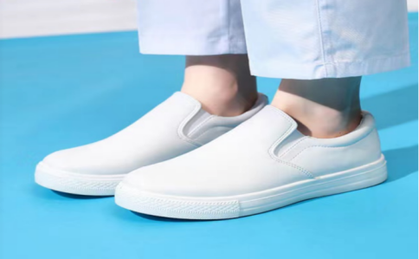

|  |  |  |  |  |  |  |  |  |  |  |  |  |
| --- | --- | --- | --- | --- | --- | --- | --- | --- | --- | --- | --- | --- |
| 护士鞋码对应尺码表 | | | | | | | | | | | | |
| 尺码 | 34 | 35 | 36 | 37 | 38 | 39 | 40 | 41 | 42 | 43 | 44 | 45 |
| 脚长（cm） | 220 | 225 | 230 | 235 | 240 | 245 | 250 | 255 | 260 | 265 | 270 | 275 |



|  |  |  |  |  |  |  |
| --- | --- | --- | --- | --- | --- | --- |
| **隔离衣尺码表** | | | | | | |
| 尺码 | 肩宽(cm） | 胸围(cm） | 袖长(cm） | 衣长(cm） | 建议身高(cm） | 建议体重（斤） |
| S | 40 | 104 | 55 | 94 | 155-160 | 90-110 |
| M | 43 | 106 | 55 | 96 | 160-165 | 105-125 |
| L | 46 | 114 | 55 | 101 | 165-170 | 120-135 |
| XL | 47 | 124 | 59 | 102 | 170-175 | 130-145 |
| XXL | 48 | 131 | 59 | 105 | 175-180 | 140-165 |
| XXXL | 51 | 134 | 61 | 106 | 180-185 | 160-185 |
| XXXXL | 54 | 140 | 61 | 106 | 180-190 | 180-220 |